**Web App for Employer**

**Goal**

1. **Employer can manage their recruitment info:**

_ Employer can login by linkedin/Facebook/google or email.

_ Edit / Input profile

_ Create/update a job post

_ View status of job post

-view all candidates profile who have applied to your job post.

_ Chat and set up interview with candidate

1. **Job seeker can update profile and get job:**

_ Job seeker can login by linkedin/Facebook/google or email

_ Edit / Input profile

_ View job by map & see job post details – apply or decline a job

_ View applied job status

_ Chat with employer

**API info:**

1. API Doc: <https://docs.google.com/spreadsheets/d/10kCb-5ap9fHizsXgdz3jxO6UmtFsulcPcsAHP3CMbb0/edit#gid=0>

2. API sever link: http://54.169.222.178/static/

3. API dev link: http://54.169.24.194/

**Detail Spec for Employer:**

**We have total 5 screens to help company can login and manage:**

1. Login Screen: User can login by email, Facebook, linkedin, google or register

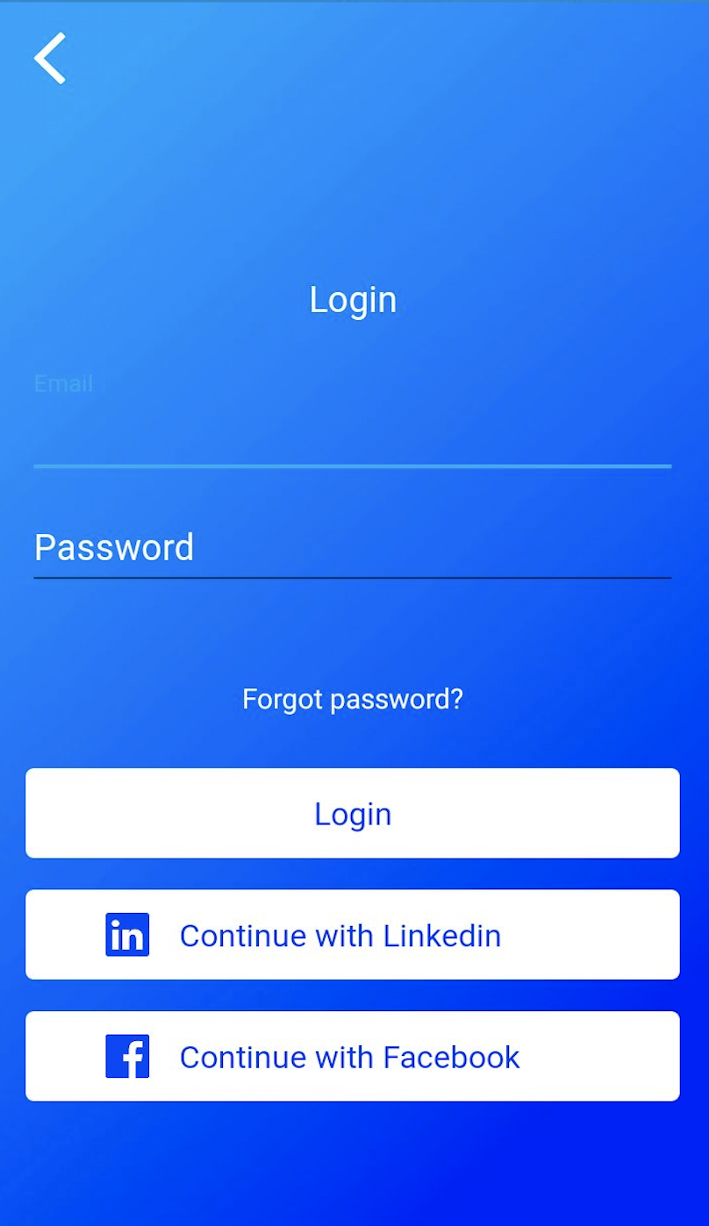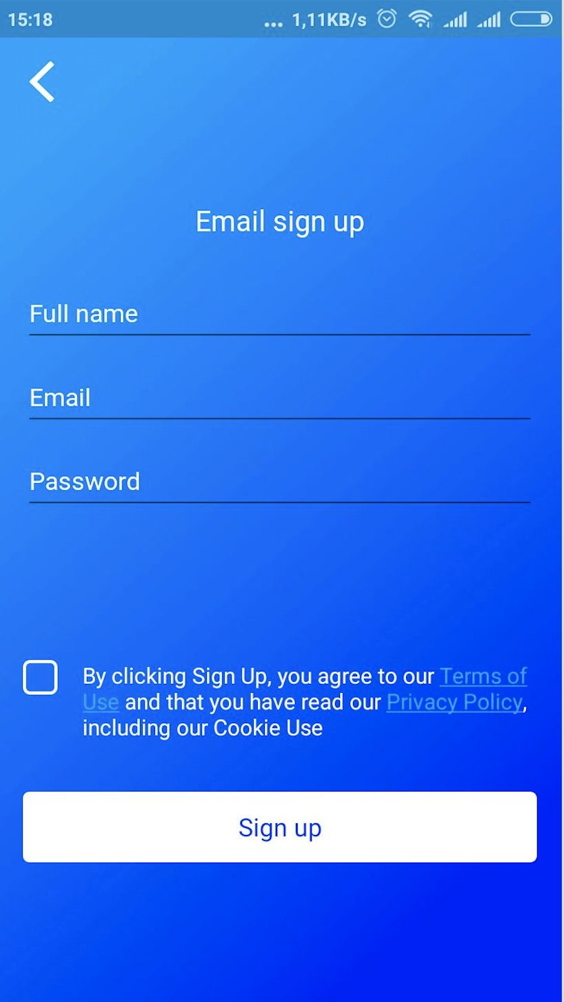

1. Input information with new company (skip with old company login).

After login, new employer need to input more information:

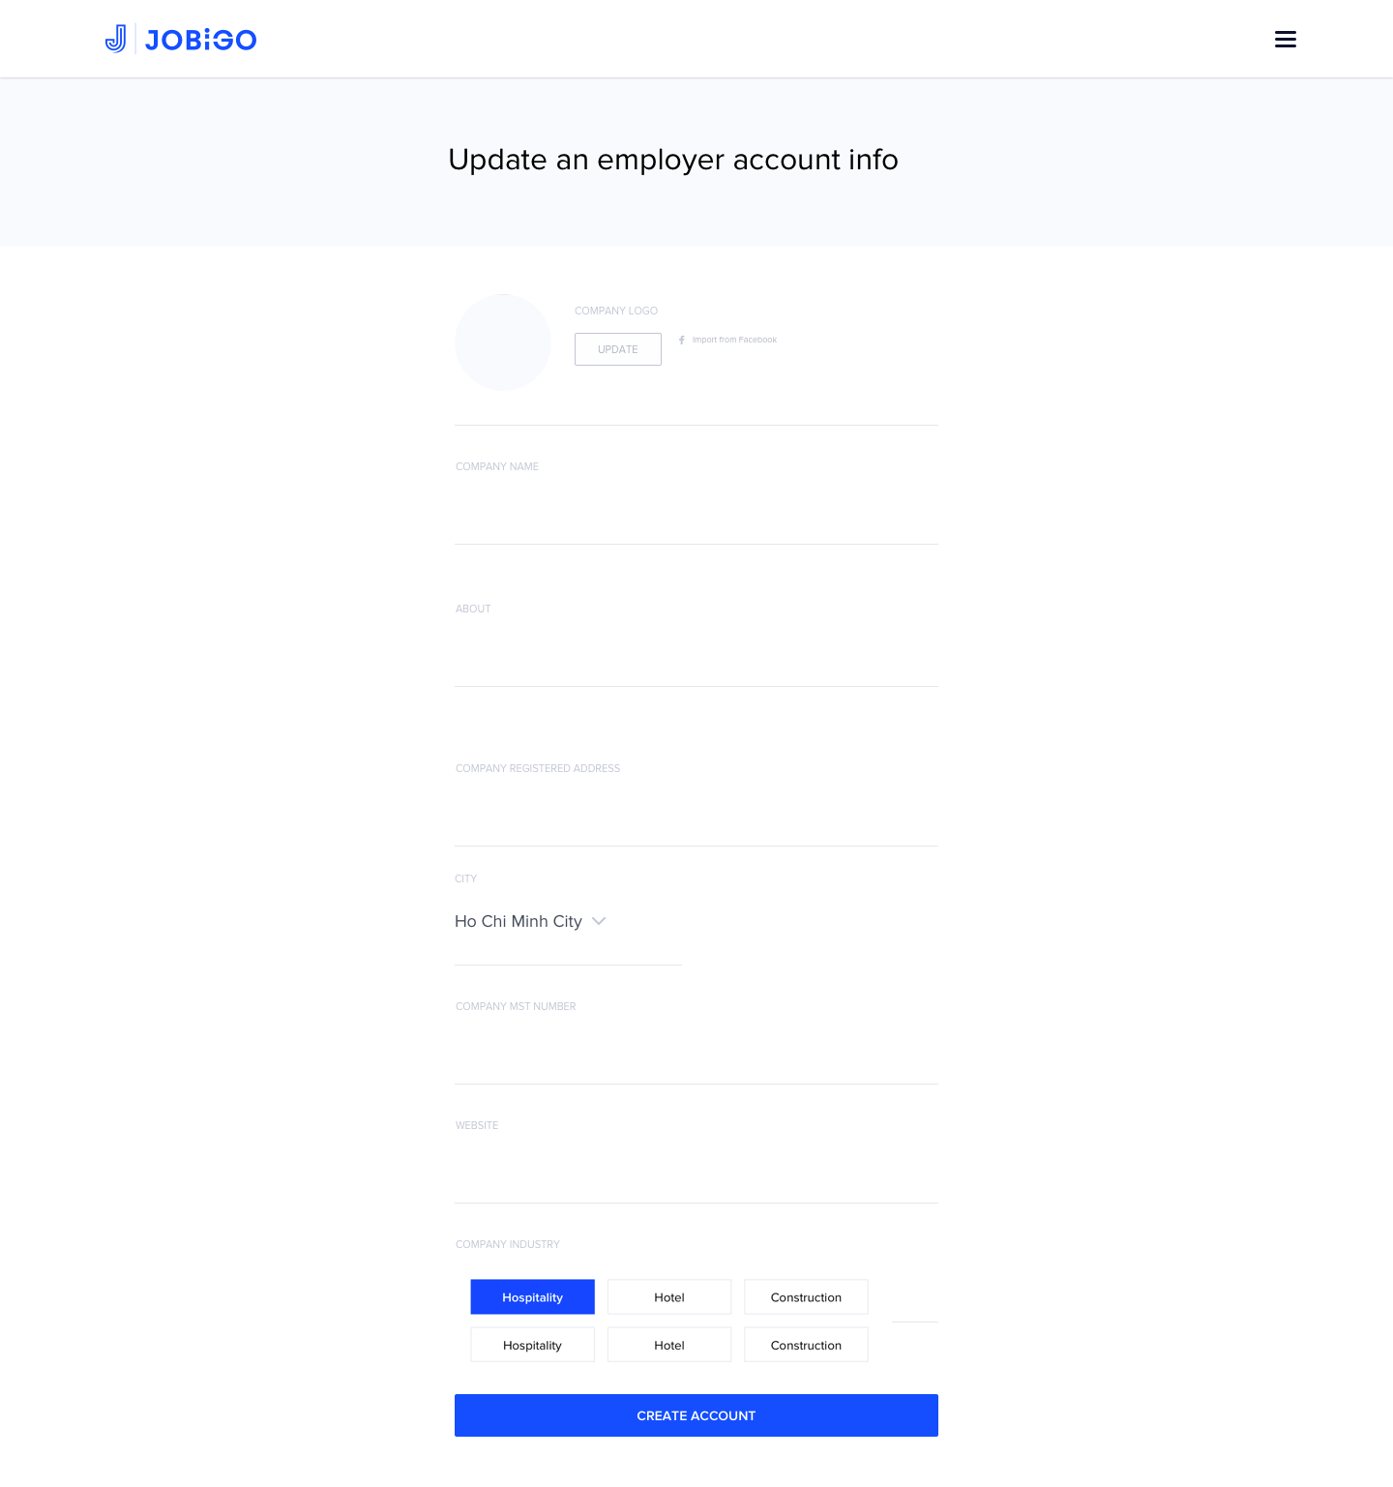

1. Dashboard Screen

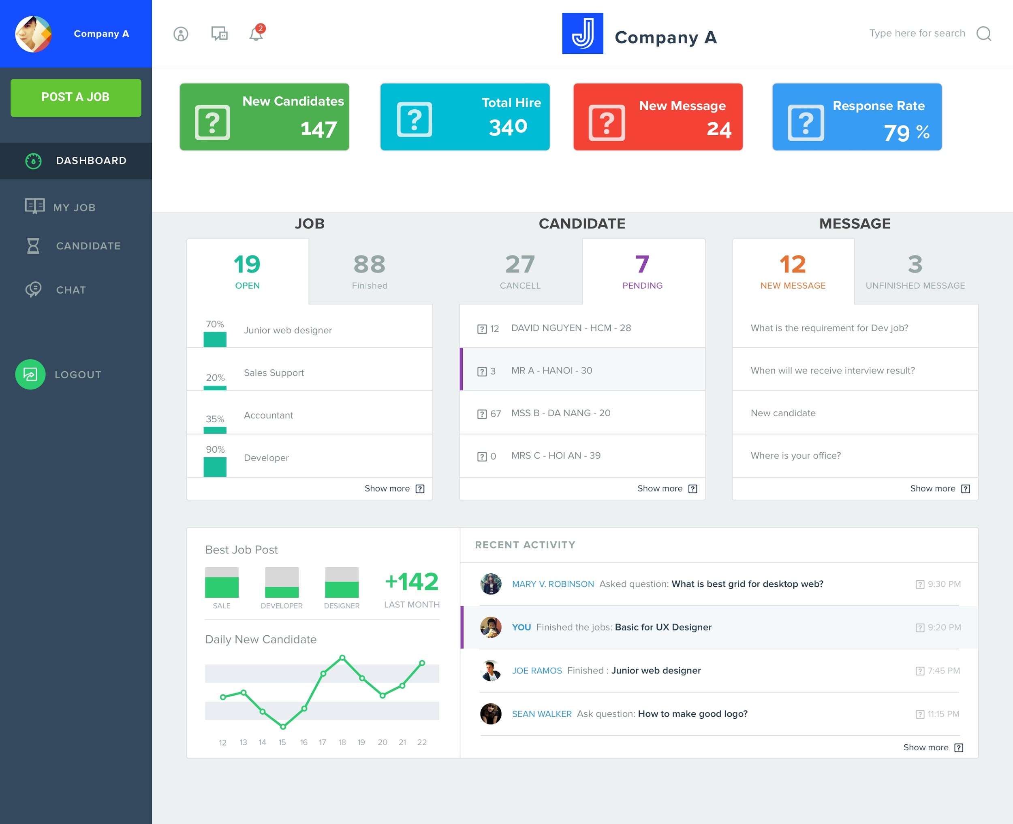

1. Post a new job:

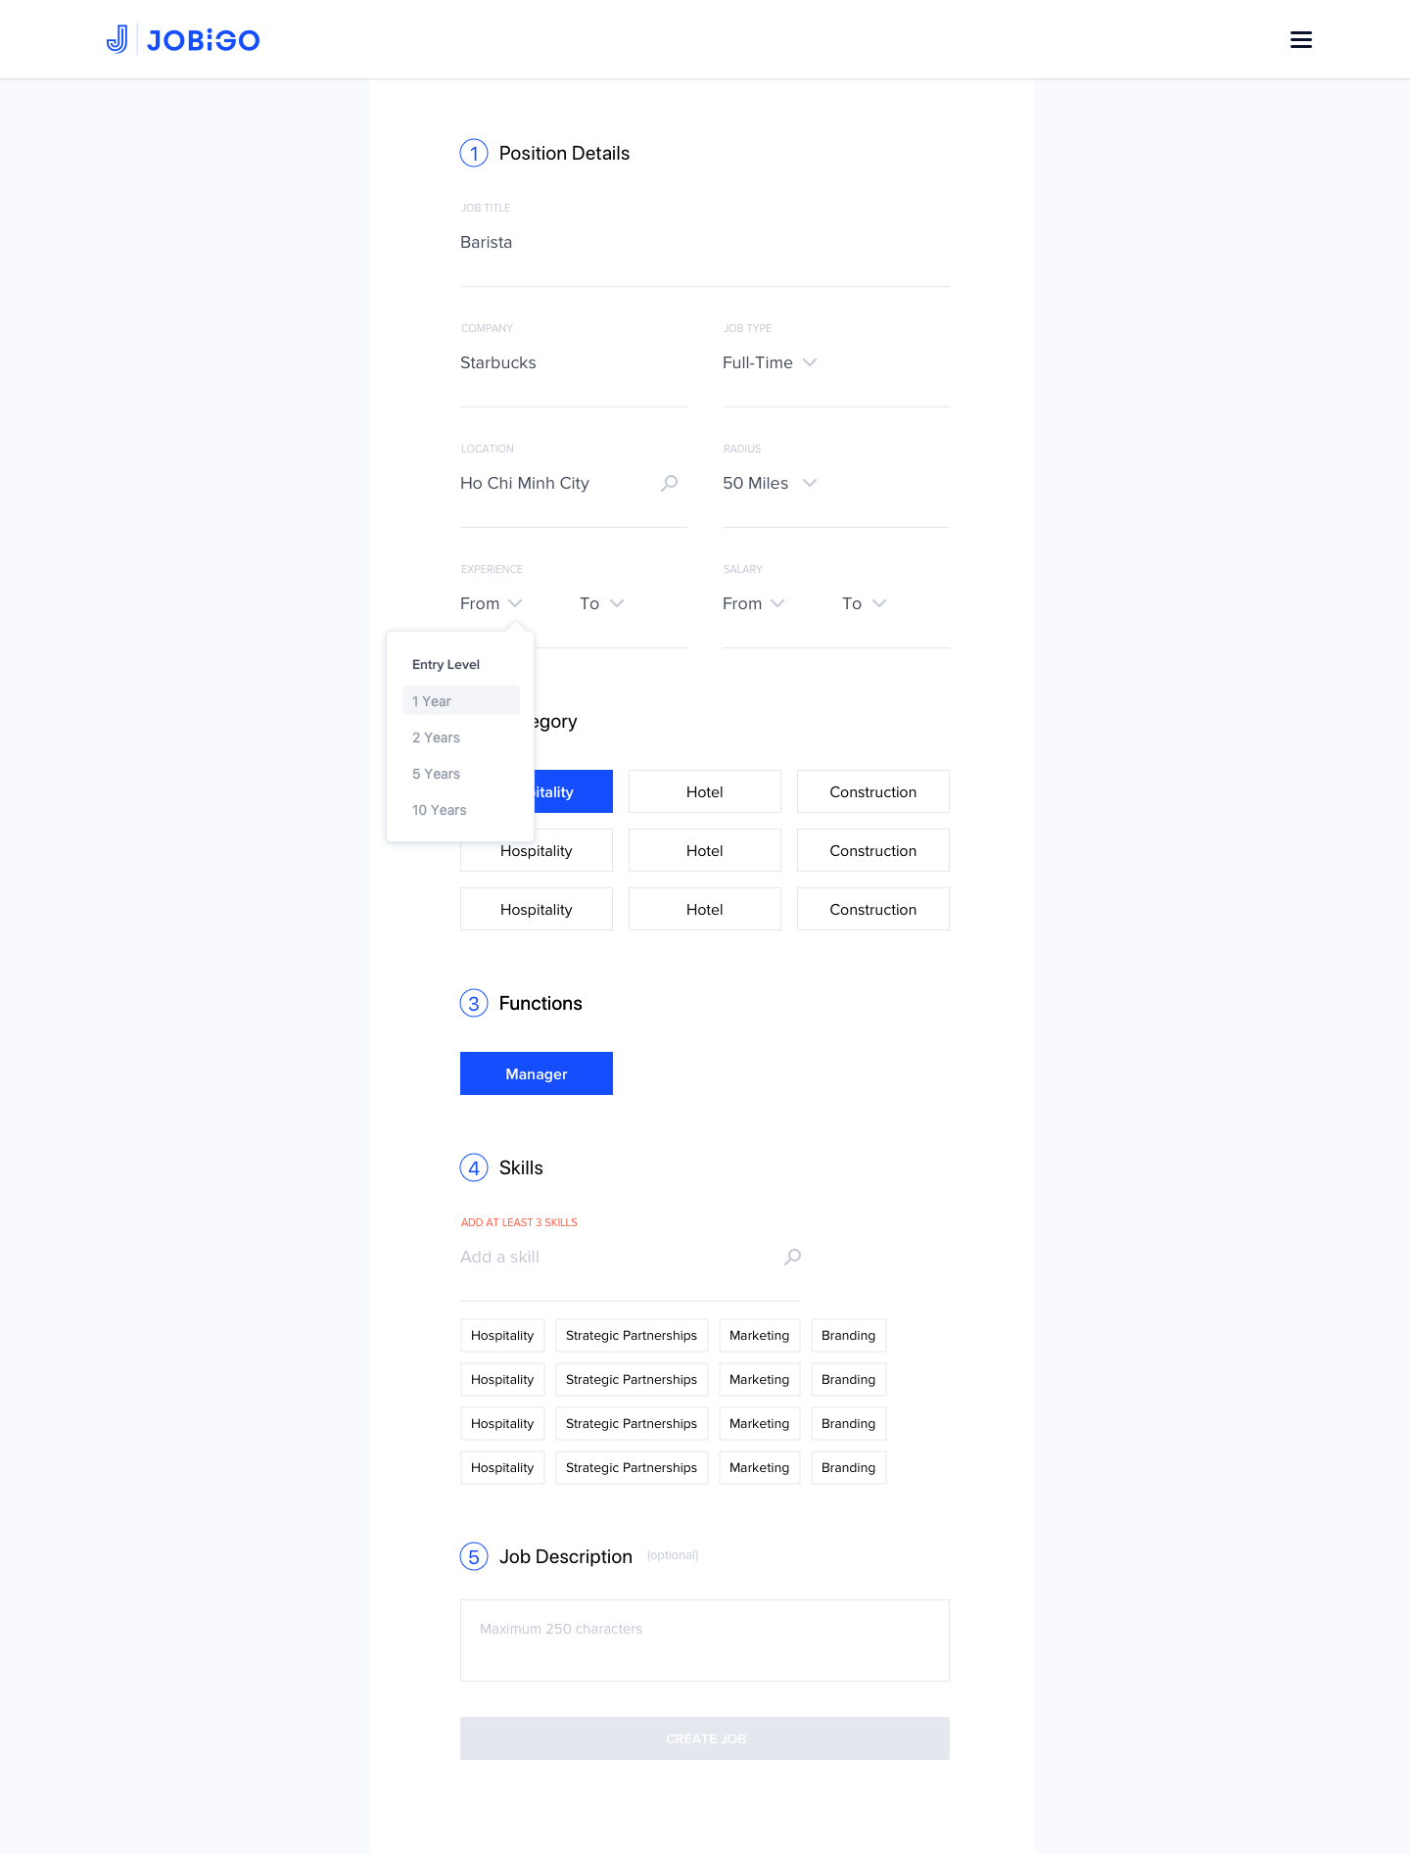

1. My Job

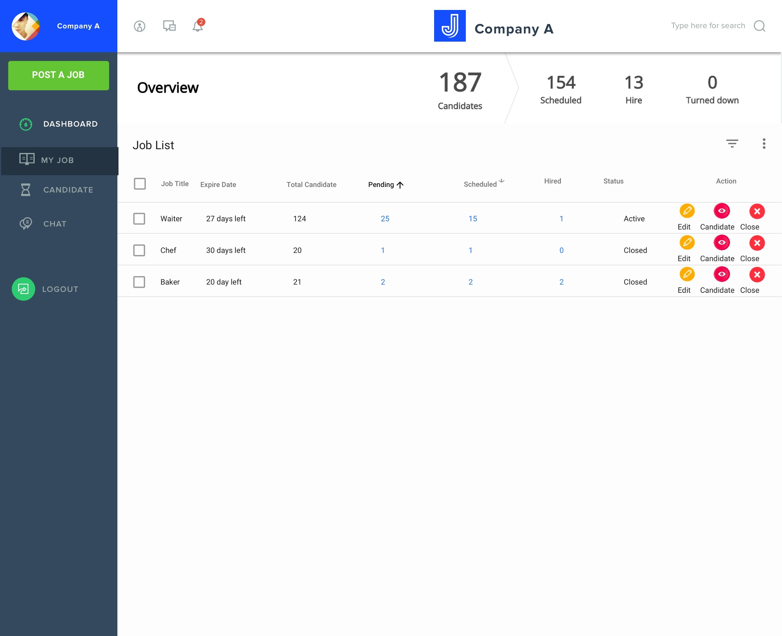

1. My Candidate

App Screen:

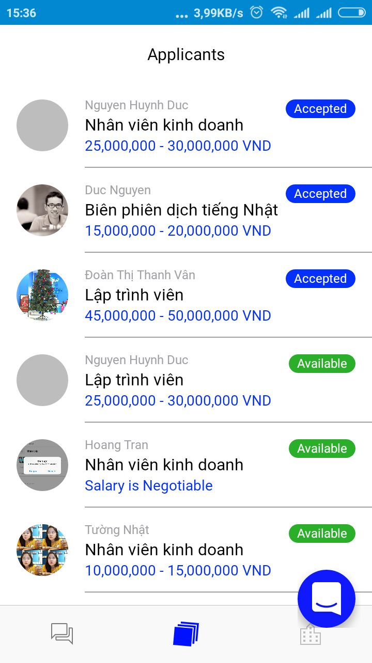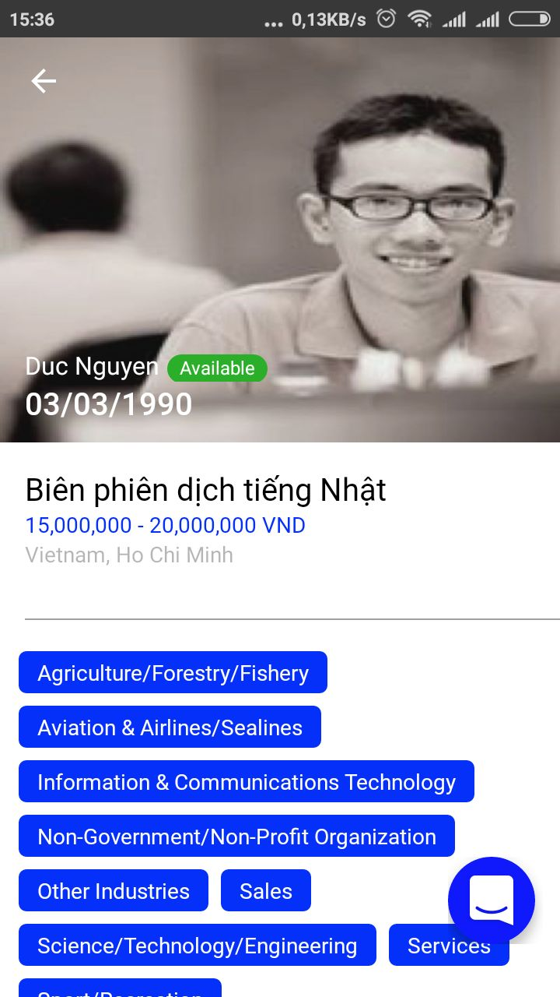

View list candidate View profile candidate

1. Chat with candidate (Using Intercom plugin)

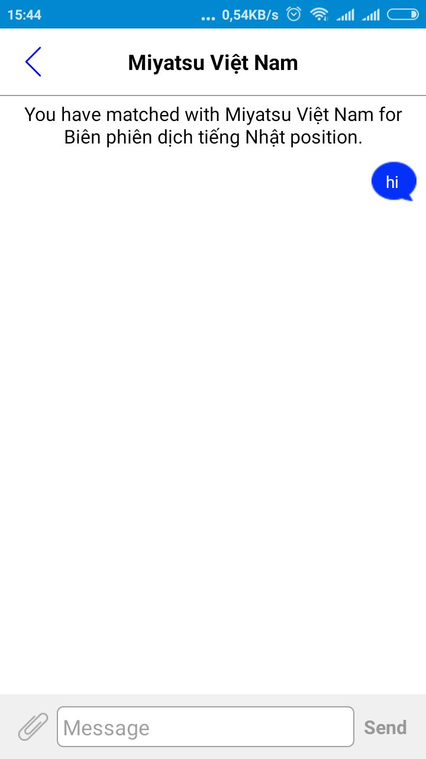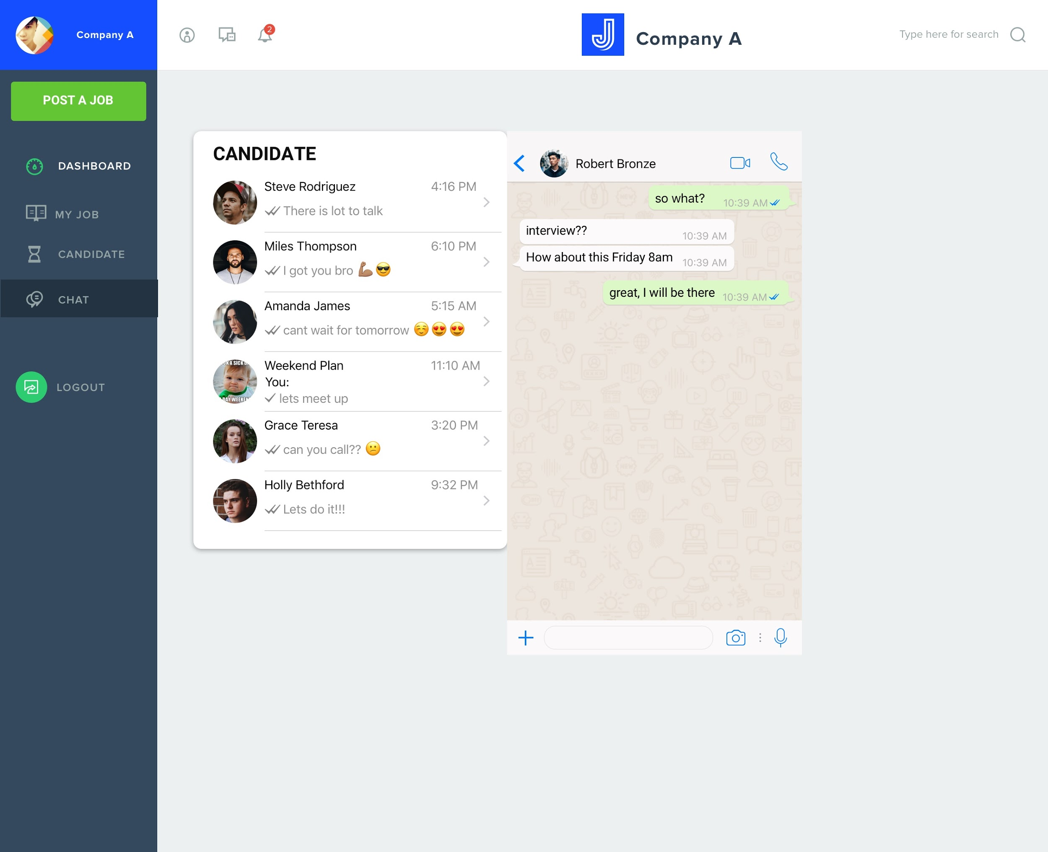

View on App On web

1. Edit Company Profile

Similar to screen number 2

**Detail Spec for Job seeker:**

1. Login Screen: User can login by email, Facebook, linkedin, google or register



1. Input information with new job seeker (skip with old login).

After login, new job seeker need to input more information:

A profile need to input 17 information:

1. Avatar picture
2. Fullname
3. Birthday
4. Username (Email got from register)
5. Location (API)
6. About me
7. Speaking language
8. Salary
9. Job type (API) (Full time/ Part time...)
10. Available from
11. Job industry (API)
12. Job function (API)
13. Experience
14. Video
15. Add CV
16. Add Workplace
17. Add Education

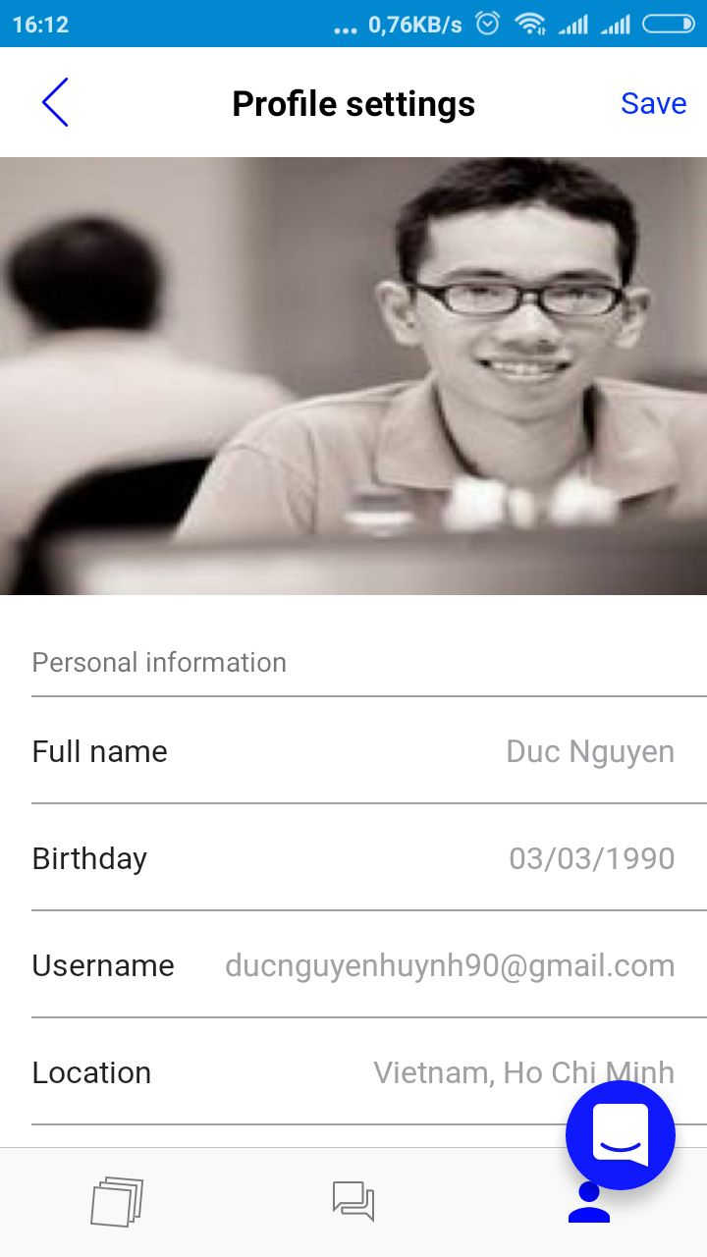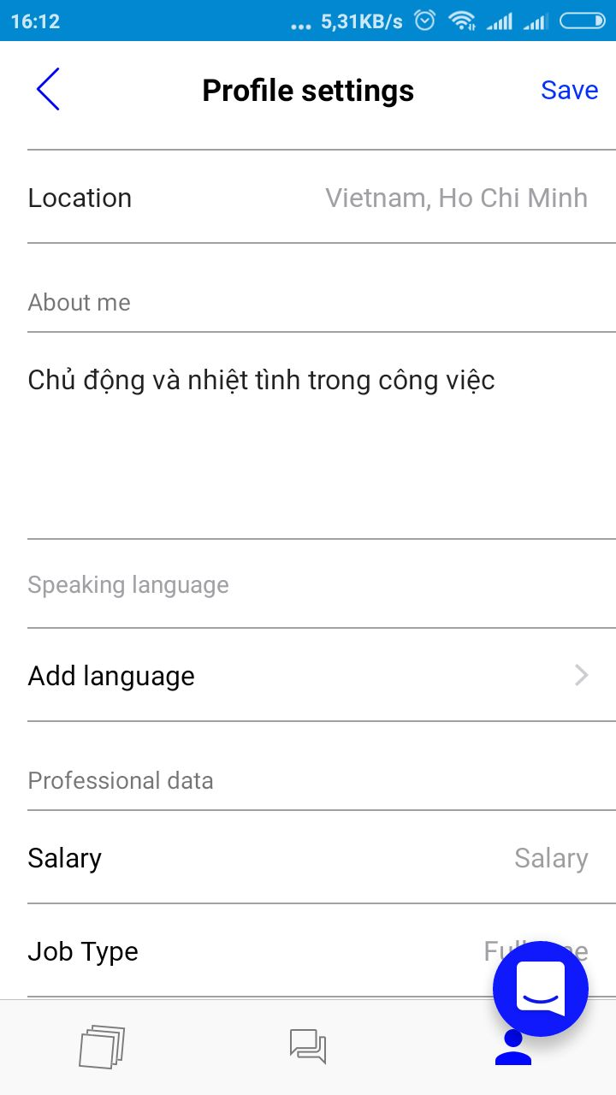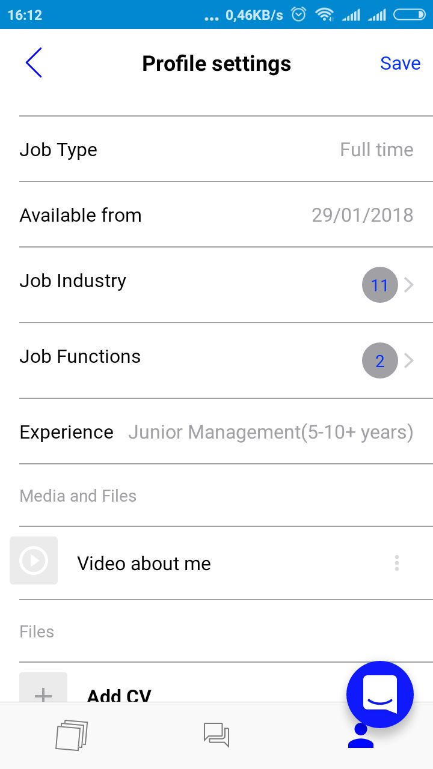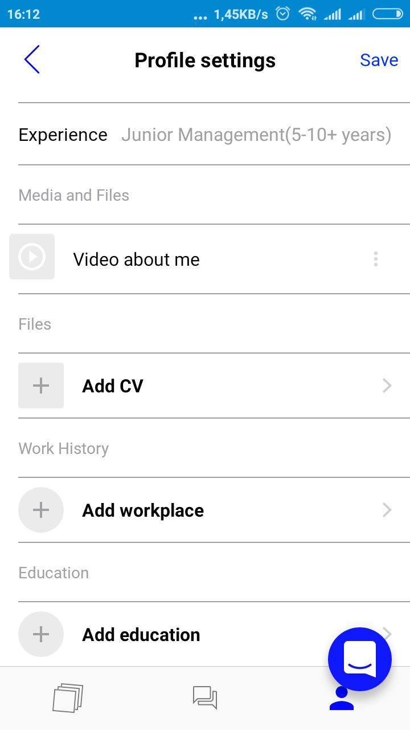

Screen from phone

1. Find job

* User can view list of job on the map:

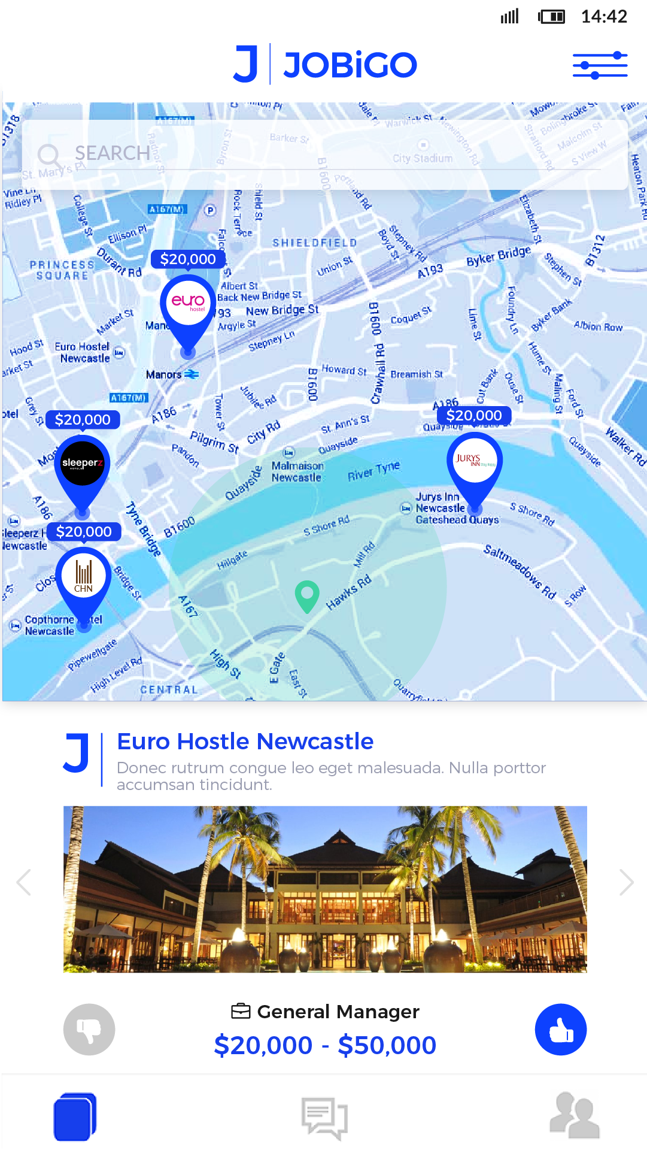

* They can click to a job to view job detail:

Info of job will be the same with list info created by employer

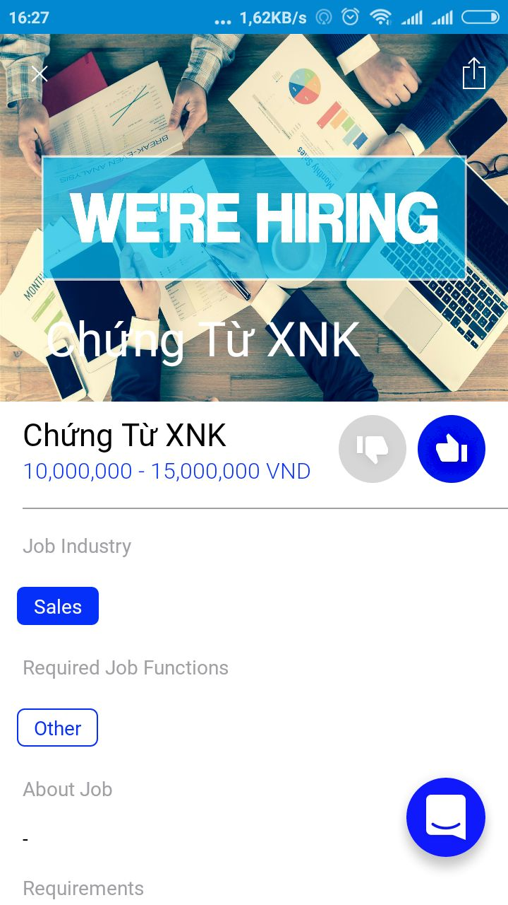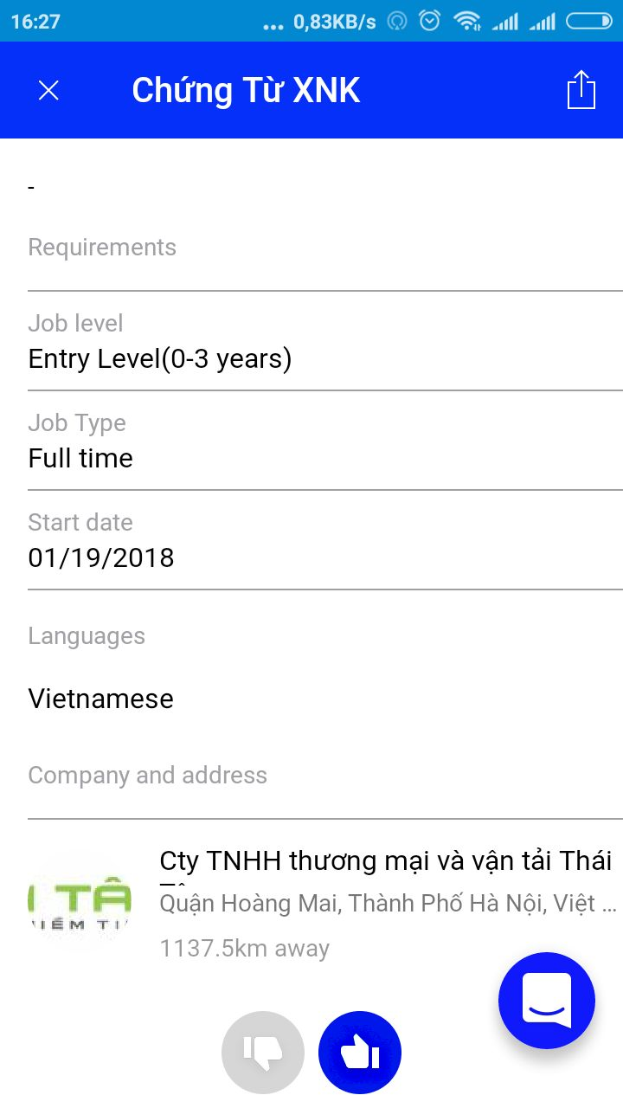

* They can click to a company to view company profile: Show company profile and their posted job.

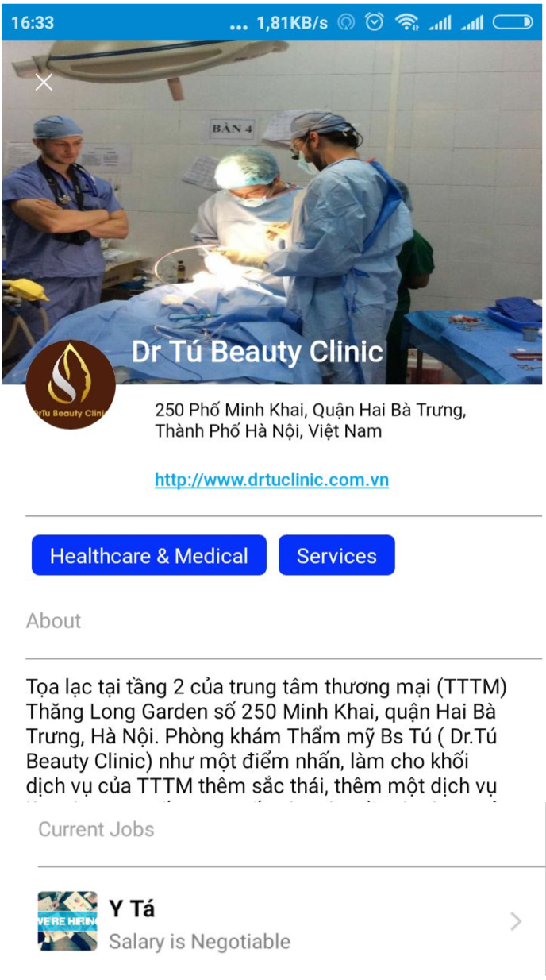

1. View the job they applied and the job got accepted by employer

**App screen show list job they applied and got accepted**

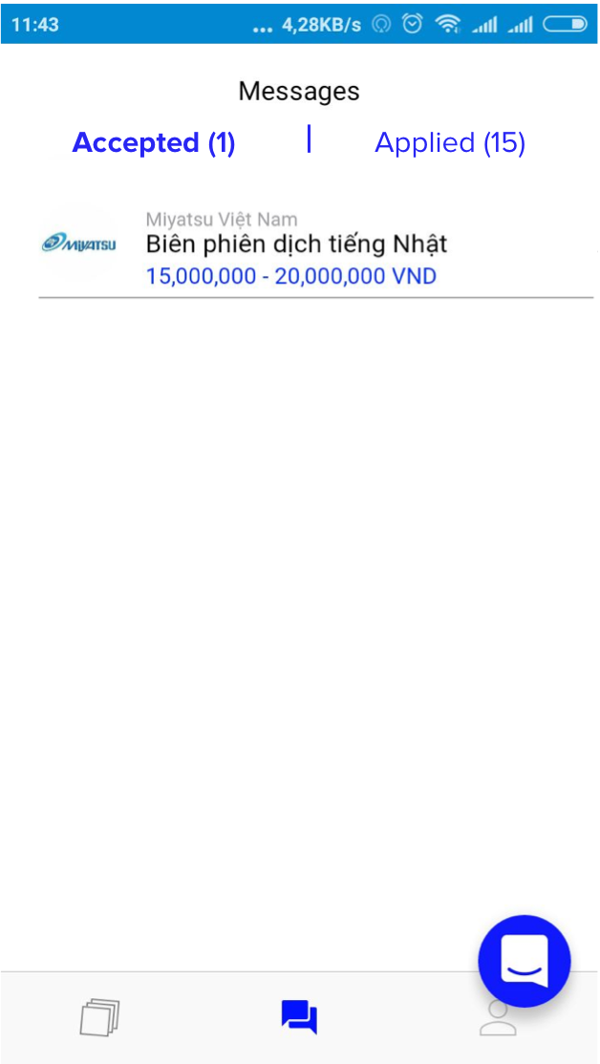

Job seeker can:

_ click to the job to view information about the job (Show the same info like “3. Find job” section)

_ chat with employer asking more about the job

1. Chat with employer

Job seeker and employer can chat and discuss about hiring process.

